Unicast

📡 What Is Unicast in Networking?
# Source: AI Source: Provided by: [Data Path: Persons Table -> ID Column: 1, Name_En Column: Motasem Essam] -> From: [ChatGPT] on [12/9/2025]
Unicast is a one-to-one communication method in a network where data is sent from one sender to one specific receiver.

📦 Belongs to:
# Source: AI Source: Provided by: [Data Path: Persons Table -> ID Column: 1, Name_En Column: Motasem Essam] -> From: [ChatGPT] on [12/9/2025]
✅ Types of Network Transmission Modes
(alongside Multicast and Broadcast)

🧠 Definition:
# Source: AI Source: Provided by: [Data Path: Persons Table -> ID Column: 1, Name_En Column: Motasem Essam] -> From: [ChatGPT] on [12/9/2025]
In unicast, the sender transmits data to a single, unique destination IP address — just one recipient.

📌 Example:
# Source: AI Source: Provided by: [Data Path: Persons Table -> ID Column: 1, Name_En Column: Motasem Essam] -> From: [ChatGPT] on [12/9/2025]
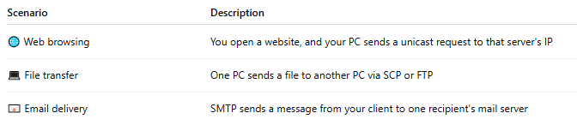
Scenario | Description
🌐 Web browsing | You open a website, and your PC sends a unicast request to that server's IP
💻 File transfer | One PC sends a file to another PC via SCP or FTP
📧 Email delivery | SMTP sends a message from your client to one recipient's mail server

🗂 Unicast Characteristics:
# Source: AI Source: Provided by: [Data Path: Persons Table -> ID Column: 1, Name_En Column: Motasem Essam] -> From: [ChatGPT] on [12/9/2025]
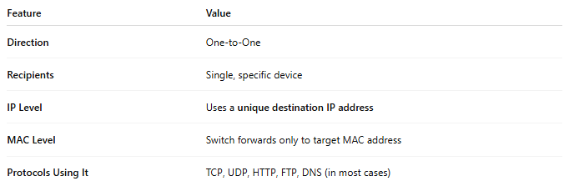

Feature | Value
Direction | One-to-One
Recipients | Single, specific device
IP Level | Uses a unique destination IP address
MAC Level | Switch forwards only to target MAC address
Protocols Using It | TCP, UDP, HTTP, FTP, DNS (in most cases)

✅ Advantages
# Source: AI Source: Provided by: [Data Path: Persons Table -> ID Column: 1, Name_En Column: Motasem Essam] -> From: [ChatGPT] on [12/9/2025]
- 🛡️ Private and direct communication
- 🔁 Allows individualized sessions (e.g., authentication, encryption)
- 🎯 Precise delivery — no unnecessary traffic to others

❌ Disadvantages
# Source: AI Source: Provided by: [Data Path: Persons Table -> ID Column: 1, Name_En Column: Motasem Essam] -> From: [ChatGPT] on [12/9/2025]
- 📊 Can generate more traffic than multicast in group scenarios
- 🧩 Doesn’t scale well for mass content delivery (like video streams)

🧮 Unicast Addressing in IP
# Source: AI Source: Provided by: [Data Path: Persons Table -> ID Column: 1, Name_En Column: Motasem Essam] -> From: [ChatGPT] on [12/9/2025]
- IPv4 example: 192.168.1.10 → 192.168.1.20
- IPv6 example: fe80::1 → fe80::2
- Routing: Each unicast packet has a single destination, and routers forward accordingly

📋 Comparison Table
# Source: AI Source: Provided by: [Data Path: Persons Table -> ID Column: 1, Name_En Column: Motasem Essam] -> From: [ChatGPT] on [12/9/2025]
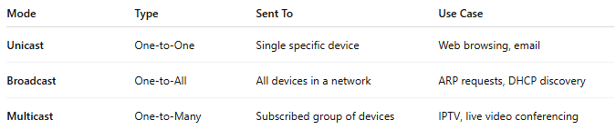
Mode | Type | Sent To | Use Case
Unicast | One-to-One | Single specific device | Web browsing, email
Broadcast | One-to-All | All devices in a network | ARP requests, DHCP discovery
Multicast | One-to-Many | Subscribed group of devices | IPTV, live video conferencing

